| **Course: CSE 462**  **LAB 7 – Building a Complete Network (Final Report)** |
| --- |

| **Student name** | *Pham Nguyen Bao Trang 2131220034*  *Nguyen Vu Phuong Trang 2131220008*  *Ha Quang Minh 1931220012* |
| --- | --- |
| **Student ID** |  |
| **Final Score** |  |

**Lab Exercise Submission**

Students are responsible for submitting the requested work files by the stated deadline for full marks. Late submissions will NOT be accepted.

**Objective:** This lab is to guide you how to build a complete network.

**NOTE:** *Students should read the guideline carefully before conducting Lab experiments and writing the final report.* **Students should write a final report in English.**

**- - - Good luck - - -**

**Students are required to perform the following tasks:**

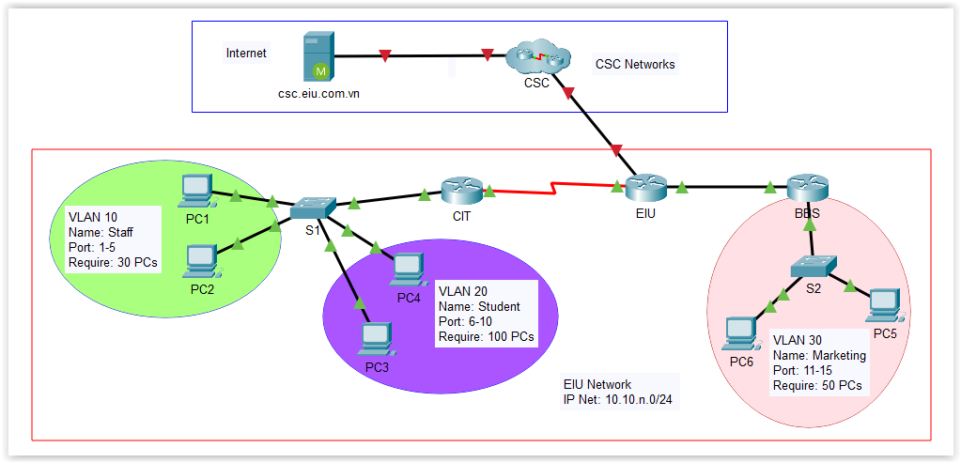

Figure 1. Network topology

**Task 1: IP Address Assigment**

Complete the following table with the correct IP Address information from the above topology.

| Device | Interface | IP Address | Subnet Mask | Default Gateway |
| --- | --- | --- | --- | --- |
| CIT | se0/0/0 | 10.10.2.225 | 255.255.255.240 | N/A |
| G0/0.10 | 10.10.2.193 | 255.255.255.224 | N/A |
| G0/0.20 | 10.10.2.1 | 255.255.255.128 | 10.10.2.1 |
| EIU | se0/0/0 | 10.10.2.226 | 255.255.255.240 | N/A |
| G0/0 | 10.10.2.241 | 255.255.255.248 | N/A |
| G0/1 | 172.16.3.120 | 255.255.255.0 | N/A |
| BBS | G0/0 | 10.10.2.242 | 255.255.255.248 | N/A |
| G0/1.30 | 10.10.2.129 | 255.255.255.192 | N/A |
| S1 | VLAN 10 | 10.10.2.194 | 255.255.255.224 | 10.10.2.193 |
| S2 | VLAN 10 | 10.10.2.195 | 255.255.255.224 | 10.10.2.193 |
| PC1 | VLAN 10 | 10.10.2.194 | 255.255.255.224 | 10.10.2.193 |
| PC2 | VLAN 10 | 10.10.2.195 | 255.255.255.224 | 10.10.2.193 |
| PC3 | VLAN 20 | Got by DHCP | 255.255.255.0 | 10.10.2.241 |
| PC4 | Got by DHCP service | Got by DHCP | 255.255.255.0 | 10.10.2.241 |
| PC5 | VLAN30 | Got by DHCP | 255.255.255.0 | 10.10.2.129 |
| PC6 | Got by DHCP service | Got by DHCP | 255.255.255.0 | 10.10.2.129 |

**Task 2: Perform Basic Configurations**

1. Assign IP address for all devices

| **CIT**  int se0/0/0  ip add 10.10.2.225 255.255.255.240  no shut  ex  int g0/0.10  encapsulation dot1q 10  ip add 10.10.2.193 255.255.255.224  no shut  ex  int g0/0.20  encapsulation dot1q 20  ip add 10.10.2.1 255.255.255.128  no shut  ex  **EIU**  int se0/0/0  ip add 10.10.2.225 255.255.255.240  no shut  int g0/0  ip add 10.10.2.241 255.255.255.248  no shut  int g0/1  ip add 172.16.3.120 255.255.255.0  no shut  **BBS**  int g0/0  ip add 10.10.2.242 255.255.255.248  no shut  int g0/1.30  encapsulation dot1q 30  ip add 10.10.2.129 255.255.255.192  no shut  ex  **S1**  vlan 10  name Staff  vlan 20  name Student  ex  int vlan 10  int range f0/1 -5  switchport mode access  switchport access vlan 10  int vlan 20  int range f0/6-10  switchport mode access  switchport access vlan 20  interface fa0/21  switchport trunk encapsulation dot1q  switchport mode trunk  switchport trunk allowed vlan 10,20  **S2**  vlan 30  name Marketing  int range f0/11-15  switchport mode access  switchport access vlan 30  ex  interface fa0/21  switchport trunk encapsulation dot1q  switchport mode trunk  switchport trunk allowed vlan 30 |
| --- |

1. Enable SSH on all Routers

| **CIT**  ip domain-name example.com  crypto key generate rsa  ! Nhập độ dài khóa, ví dụ: 2048  2048  username admin privilege 15 secret cisco@123  line vty 0 4  transport input ssh  login local  exit  ip ssh version 2  ip ssh time-out 60  ip ssh authentication-retries 3 EIU ip domain-name example.com  crypto key generate rsa  ! Nhập độ dài khóa, ví dụ: 2048  2048  username admin privilege 15 secret 123  line vty 0 4  transport input ssh  login local  exit  ip ssh version 2  ip ssh time-out 60  ip ssh authentication-retries 3 BBS ip domain-name example.com  crypto key generate rsa  ! Nhập độ dài khóa, ví dụ: 2048  2048  username admin privilege 15 secret 123  line vty 0 4  transport input ssh  login local  exit  ip ssh version 2  ip ssh time-out 60  ip ssh authentication-retries 3 |
| --- |

1. Perform all necessary configuration to connect all devices in the network.

| CIT router rip  version 2  network 10.10.2.0  network 10.10.2.192  network 10.10.2.224  ex  ip dhcp pool vlan20  network 10.10.2.0 255.255.255.128  default-router 10.10.2.1  ex  ip dhcp excluded-address 10.10.2.1 10.10.2.10 EIU router rip  version 2  network 10.10.2.240  network 10.10.2.224  ex  ip route 172.16.3.0 255.255.255.0 g0/1  ip route 0.0.0.0 0.0.0.0 172.16.3.1  %Default route without gateway, if not a point-to-point interface, may impact performance  router rip  network 172.16.3.0  redistribute static  ip nat inside source list 1 int g0/1 overload  int g 0/0  ip nat inside  int se0/0/0  ip nat inside  int g0/1  ip nat outside  access-list 1 permit 10.10.2.0 0.0.0.127  access-list 1 permit 10.10.2.128 0.0.0.63  access-list 1 permit 10.10.2.192 0.0.0.31  access-list 1 permit 10.10.2.224 0.0.0.15  access-list 1 permit 10.10.2.240 0.0.0.7  access-list 1 permit 10.10.2.248 0.0.0.3 BBS router rip  version 2  network 10.10.2.128  network 10.10.2.240  ex  ip dhcp pool vlan30  network 10.10.2.128 255.255.255.192  default-router 10.10.2.129  ex  ip dhcp excluded-address 10.10.2.129 10.10.2.139 |
| --- |

| **PC3**    **PC4** |
| --- |

1. Verity the connection between PCs, Router and other devices.

| **PC1 → Router EIU** |
| --- |

1. Make sure all computers can access SSH to all routers.

| DONE |
| --- |

**Task 3: Configure DHCP service**

In this task, Router EIU is configured as a DHCP server to provide IP address

dynamically for two VLAN Student and VLAN Marketing.

| **CIT**  ip dhcp pool vlan20  network 10.10.2.0 255.255.255.128  default-router 10.10.2.1  ex  ip dhcp excluded-address 10.10.2.1 10.10.2.10  **BBS**  ip dhcp pool vlan30  network 10.10.2.128 255.255.255.192  default-router 10.10.2.129  ex  ip dhcp excluded-address 10.10.2.129 10.10.2.139 |
| --- |

1. Perform all necessary configuration to complete this task.

| **PC3**    **PC4**    Gặp khó khăn nếu quên viết  **Router BBS**  int g0/1.30  encapsulation dot1q 30  ip add 10.10.2.129 255.255.255.192  no shut  ex  int g0/1  no shut  **PC5**    **PC6** |
| --- |

1. Check IP address for PCs in Marketing and Student VLAN when enabling DHCP service

**DONE**

1. **Verify DHCP services and address leases on Router EIU**

**DONE**

**Task 4: Configure NAT Service**

In this task, Router EIU is configured as a Gateway to Public network (Internet)

NOTE: We use the network of 172.16.3.0/24 as public IP address to access Internet

1. Configure appropriate devices to allow all devices in EIU network connect to Internet.

| **EIU**  ip nat inside source list 1 int g0/1 overload  int g 0/0  ip nat inside  int se0/0/0  ip nat inside  int g0/1  ip nat outside  access-list 1 permit 10.10.2.0 0.0.0.127  access-list 1 permit 10.10.2.128 0.0.0.63  access-list 1 permit 10.10.2.192 0.0.0.31  access-list 1 permit 10.10.2.224 0.0.0.15  access-list 1 permit 10.10.2.240 0.0.0.7  access-list 1 permit 10.10.2.248 0.0.0.3  **Update : EIU là nơi cấp DHCP**  **EIU**  ip dhcp excluded-address 10.10.2.1 10.10.2.10  ip dhcp excluded-address 10.10.2.129 10.10.2.139  ip dhcp excluded-address 10.10.2.193 10.10.2.199  ip dhcp pool VLAN10  network 10.10.2.0 255.255.255.128  default-router 10.10.2.1  dns-server 8.8.8.8  ip dhcp pool VLAN20  network 10.10.2.128 255.255.255.192  default-router 10.10.2.129  dns-server 8.8.8.8  ip dhcp pool VLAN30  network 10.10.2.192 255.255.255.224  default-router 10.10.2.193  dns-server 8.8.8.8  **BBS :**  ip route 0.0.0.0 0.0.0.0 10.10.2.1 |
| --- |

1. Test Internet connection from local EIU network to Internet

**Task 5: Access Control**

Use ACL to complete the following requirements:

| access-list 100 deny icmp 10.10.2.0 0.0.0.127 any  access-list 100 deny tcp 10.10.2.0 0.0.0.127 any eq 22  access-list 100 permit ip any any  interface g0/0  ip access-group 100 in  exit |
| --- |

1. Make sure all PCs can access to PING, SSH to Routers and access to the Internet before going to next steps.
2. Users in Student VLAN (20) are allowed to connect to Internet, but cannot PING or SSH to all routers in the EIU network. However, users in Staff and Management VLAN can do.